EXPERIMENT :1
1.Create a Kanban Board to Visualize the Tasks.
• Create Columns for To Do, In-Progress and Done.
• Add Atleast 5 Sample Tasks
• Move the Tasks across the Columns to Simulate the Workflow.
Aim:
To create a simple Kanban board with task flow visualization.
Procedure:
- Create 3 columns: To Do, In-Progress, Done.
- Add 5 tasks (e.g., UI Design, Login Module, Database Setup, API Code, Testing).
- Place all tasks in “To Do”.
- Move tasks to “In-Progress” when started.
- Move tasks to “Done” after completion.
OUTPUT:
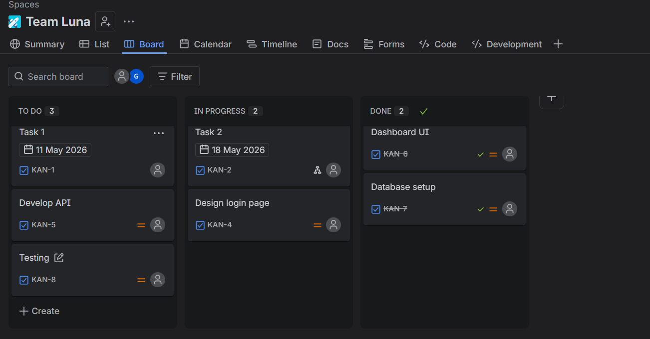
Result:
A Kanban board is created and tasks are moved across columns, showing workflow clearly.

EXPERIMENT 2
Sketch a Simple Prototype of a Bus Ticket Booking System using Figma Tool
Aim:
To design a basic prototype of a Bus Ticket Booking System using Figma.
Procedure:
- Open Figma and create a new design file.
- Create frames for main screens (Mobile/Desktop).
- Design the following screens:
  - Home Screen: Enter source, destination, date
  - Search Results: List of available buses
  - Seat Selection: Choose seats visually
  - Booking Page: Enter passenger details
  - Payment Page: Payment options
  - Confirmation Page: Ticket details
- Use buttons, text fields, and icons to build UI.
- Link screens using prototype mode (navigation flow).
OUTPUT
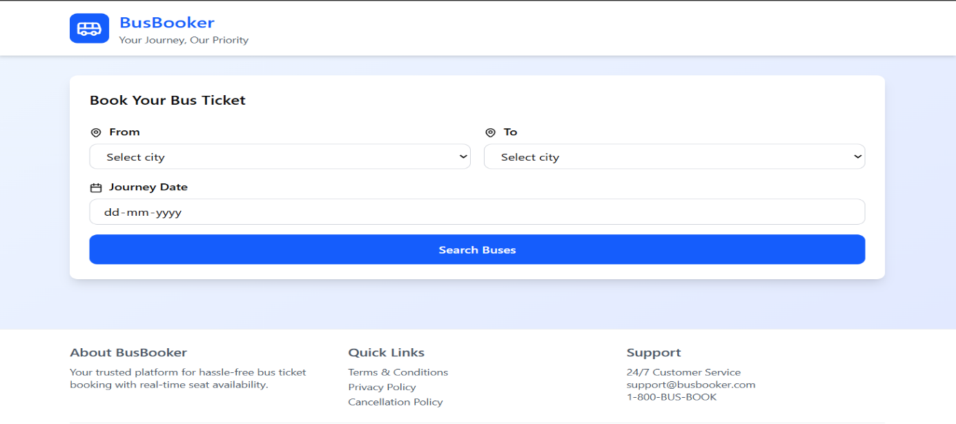
Result:
A simple interactive prototype of a bus ticket booking system is created in Figma, showing the complete booking flow from search to confirmation.

EXPERIMENT 3
The stakeholders have conflicting views on the user interface design for an E-Commerce mobile app. Create a prototype using Figma tool to discuss with the stakeholders to get their feedback and approval.
Aim:
To create a prototype of an E-Commerce mobile app using Figma to resolve stakeholder conflicts and gather feedback.
Procedure:
- Open Figma and create a new mobile design file.
- Identify key screens:
  - Home Page
  - Product Listing
  - Product Details
  - Cart
  - Checkout
- Design 2 alternative UI versions (e.g., minimal vs. detailed layout) to address different stakeholder preferences.
- Add buttons, images, and navigation elements.
- Use Prototype mode to connect screens (simulate user flow).
- Share the prototype link with stakeholders.
- Collect feedback (comments, suggestions).
- Refine the design based on agreed decisions.
OUTPUT
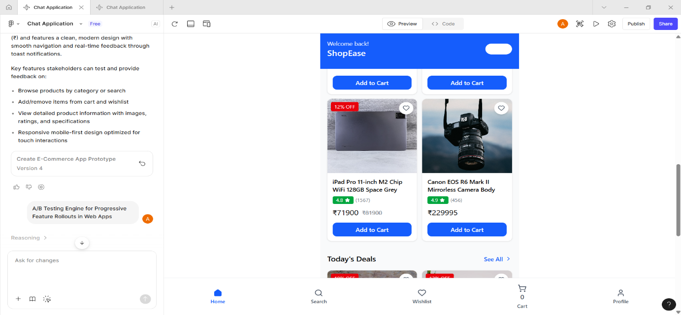
Result:
An interactive Figma prototype is created with multiple UI options, helping stakeholders compare designs, provide feedback, and finalize the user interface efficiently.

EXPERIMENT-4
Create a Scrum Project in Jira. • Add a backlog with at least 5 items (e.g., "Create user registration page", "Develop API for login").
• Prioritize the backlog and create a 1-week sprint.
• Move backlog items into the sprint and start the sprint.
• Finally show the Screenshot of the sprint board at the start and end of the sprint.
Aim:
To create a Scrum project in Jira, manage backlog items, and track sprint progress.
Procedure:
- Open Jira → Create a new Scrum Project.
- Add backlog items (minimum 5):
  - Create user registration page
  - Develop login API
  - Design homepage UI
  - Implement database
  - Test login functionality
- Prioritize backlog (drag items based on importance).
- Create a 1-week sprint.
- Move selected backlog items into the sprint.
- Start the sprint.
- At sprint start → all tasks appear in To Do column (take screenshot).
- During progress → move tasks to In Progress and then Done.
- At sprint end → all completed tasks in Done column (take screenshot).
OUTPUT
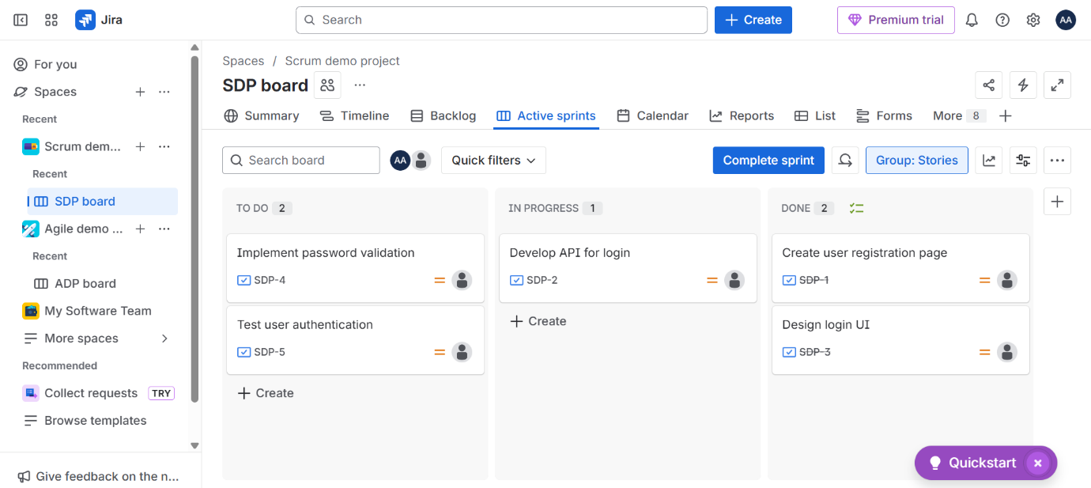
Result:
A Scrum project is successfully created in Jira with a prioritized backlog and a 1-week sprint. Tasks are tracked from To Do → In Progress → Done, and sprint board screenshots show progress at the start and end.

EXPERIMENT 5
Use the following requirements for a Library Management System:
• Add a feature to search books by title and author.
• Implement an online book reservation system.
• Generate monthly reports on borrowed books for administrators.
• Enable email notifications for overdue books.
• Add support for QR code scanning for borrowing and returning books.
• Create a user-friendly dashboard for librarians.
• Allow users to review and rate books.
• Integrate a chatbot for user assistance.
• Develop a mobile app version of the system.
• Provide multi-language support. Categorize each requirement using MOSCOW Method (Must-Have, Should-Have, Could-Have, or Won’t-Have) based on the following criteria:
• Impact on the users and stakeholders.
• Feasibility considering time, budget, and resource constraints.
Finally Submit the completed Google Sheet or Excel file with all requirements categorized and justified.
Aim:
To categorize the Library Management System requirements using the MoSCoW method based on user impact and feasibility, and document them in an Excel/Google Sheet.
Procedure:
- List all given system requirements.
- Analyze each requirement based on:
  - Importance to users/stakeholders
  - Feasibility (time, cost, resources)
- Categorize requirements into:
  - Must-Have (essential features)
  - Should-Have (important but not critical)
  - Could-Have (optional enhancements)
  - Won’t-Have (deferred for later)
- Create an Excel/Google Sheet with columns:
Requirement | Category | Justification
- Enter all categorized requirements with proper justification.
- Save and submit the file.
OUTPUT
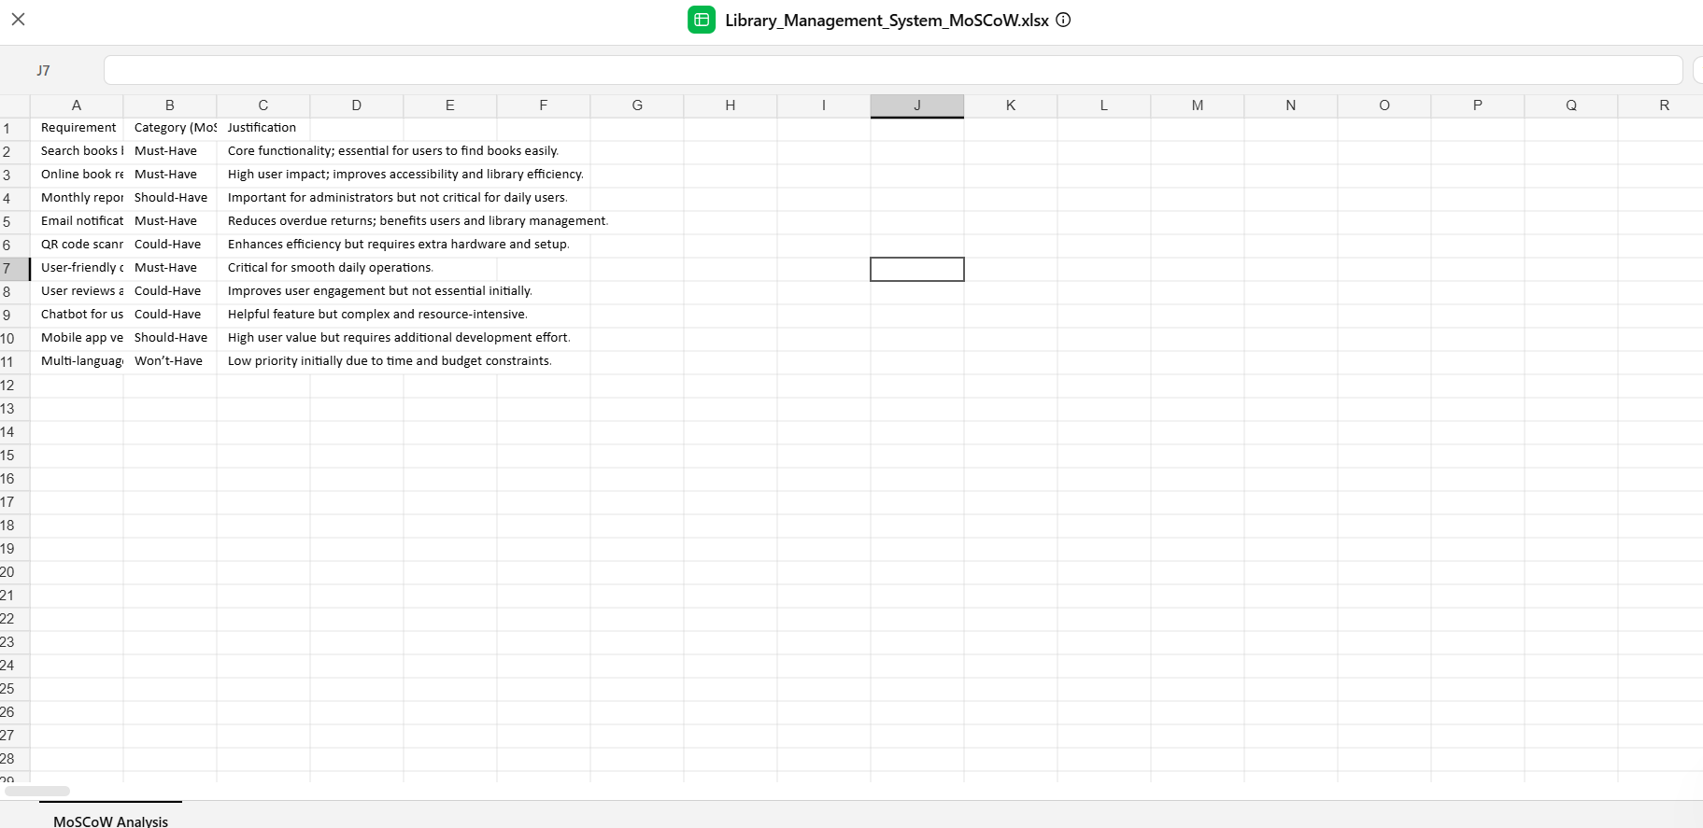
Result:
All requirements are successfully classified using the MoSCoW method and documented in an Excel/Google Sheet, helping prioritize development based on impact and feasibility.

EXPERIMENT 6
Link Jira tasks with Confluence to streamline task tracking and progress monitoring for the Library Management System development.
• Create a new page in Confluence titled "Library Management System Project Overview."
• Embed at least 5 Jira issues related to the development of the Library Management System (e.g., tasks from the sprint like "Develop book search functionality," "Create user login page," etc.).
• Use the Jira macro to display issues with status (e.g., "To Do," "In Progress," "Done").
• Add a progress bar in the Confluence page to visually track the completion of each embedded Jira task (e.g., percentage of tasks completed in the sprint).
• Submit a screenshot of the Confluence page showing the embedded Jira tasks and the progress bar.
Aim:
To integrate Jira with Confluence for efficient task tracking and progress monitoring of the Library Management System.
Procedure:
- Open Confluence → Create a new page titled “Library Management System Project Overview.”
- Click Insert (+) → Jira Issue/Filter (Jira Macro).
- Add at least 5 Jira issues, such as:
  - Develop book search functionality
  - Create user login page
  - Implement reservation system
  - Setup database
  - Add email notification feature
- Configure the Jira macro to display status columns (To Do, In Progress, Done).
- Arrange the issues in a table or list view for clarity.
- Add a progress bar:
  - Type /progress in Confluence
  - Set value (e.g., 60%) based on completed tasks
- Format the page with headings and sections for better readability.
- Save the page and take a screenshot showing:
  - Embedded Jira issues
  - Status tracking
  - Progress bar
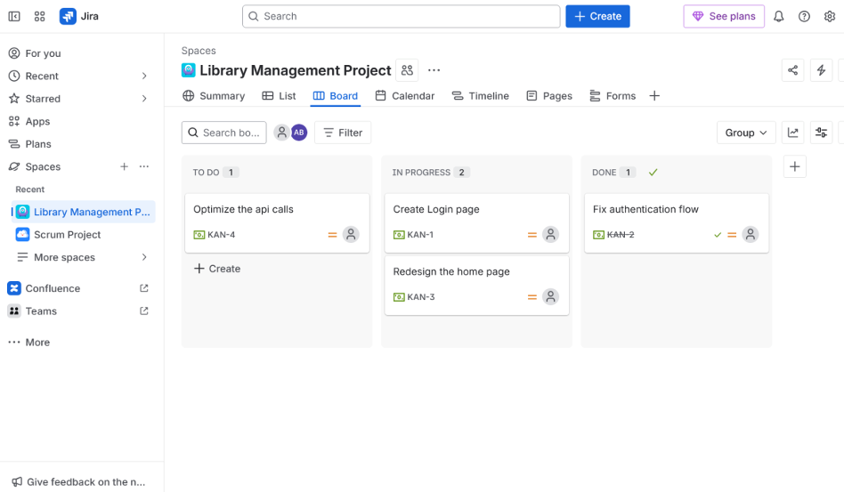
Result:
A Confluence page is successfully created with embedded Jira tasks and a progress bar, enabling clear visualization of task status and overall project progress.

EXPERIMENT 7
You are designing a Task Management System for a small team. The system should include the following features:
1.User Login and Role Assignment
2.Task Creation and Assignment
3.Task Prioritization and Deadlines
4.Progress Tracking and Reporting Prioritize these requirements using the MoSCoW and Kano models in Jira.
Aim:
To prioritize Task Management System features using MoSCoW and Kano models in Jira for better planning and user satisfaction.
Procedure:
- Open Jira → Create a new project.
- Add issues for each requirement:
  - User Login and Role Assignment
  - Task Creation and Assignment
  - Task Prioritization and Deadlines
  - Progress Tracking and Reporting
- Create custom fields or labels for:
  - MoSCoW (Must, Should, Could, Won’t)
  - Kano (Basic, Performance, Excitement)
- Categorize each requirement:
MoSCoW:
  - Must-Have: User Login and Role Assignment, Task Creation and Assignment
  - Should-Have: Task Prioritization and Deadlines
  - Could-Have: Progress Tracking and Reporting
  - Won’t-Have: None (future scope)
Kano Model:
  - Basic Needs: User Login and Role Assignment, Task Creation and Assignment
  - Performance Needs: Task Prioritization and Deadlines
  - Excitement Needs: Progress Tracking and Reporting
- Update issues with labels and priorities in Jira.
- View them in backlog or board for planning.
OUTPUT:
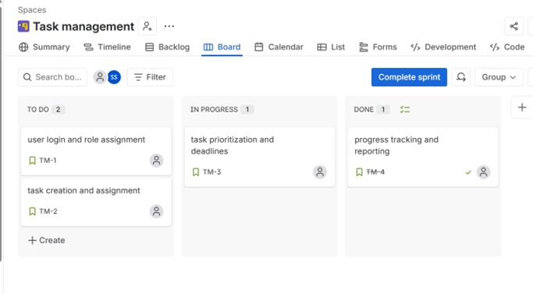
Result:
The system requirements are successfully prioritized in Jira using MoSCoW and Kano models, enabling effective task management and improved decision-making.

EXPERIMENT 8
Aim:
To categorize and prioritize Online Learning Platform features using MoSCoW and Kano models in Jira.
Procedure:
- Open Jira → Create a new project.
- Add issues for each feature:
  - Course Enrollment and Registration
  - Video Lecture Streaming
  - Interactive Quizzes and Assignments
  - Progress Tracking Dashboard
  - Peer-to-Peer Discussion Forums
  - Certificate Generation
- Create labels/custom fields:
  - MoSCoW (Must, Should, Could, Won’t)
  - Kano (Basic, Performance, Excitement)
- Assign categories:
MoSCoW Classification:
  - Must-Have:
    - Course Enrollment and Registration
    - Video Lecture Streaming
  - Should-Have:
    - Interactive Quizzes and Assignments
    - Progress Tracking Dashboard
  - Could-Have:
    - Peer-to-Peer Discussion Forums
    - Certificate Generation
  - Won’t-Have:
    - Advanced AI features (future scope)
Kano Model Classification:
  - Basic Needs:
    - Course Enrollment and Registration
    - Video Lecture Streaming
  - Performance Needs:
    - Interactive Quizzes and Assignments
    - Progress Tracking Dashboard
  - Excitement Needs:
    - Peer-to-Peer Discussion Forums
    - Certificate Generation
- Update all issues with these labels in Jira and arrange them in backlog.

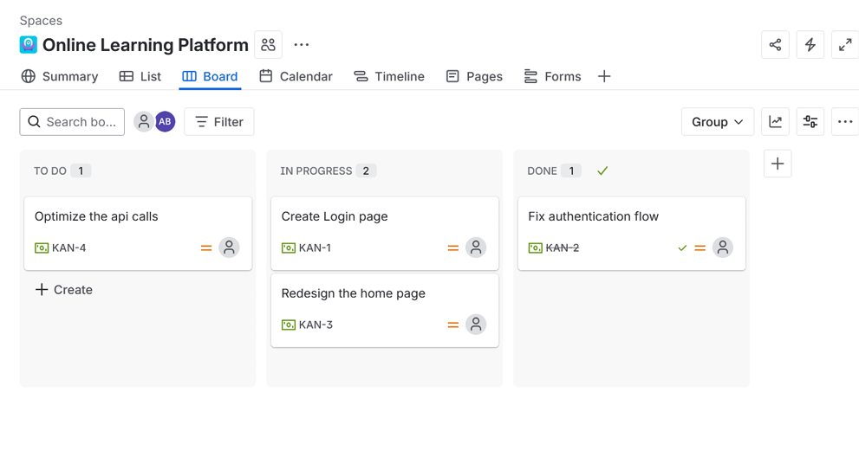
Result:
All platform requirements are successfully prioritized using MoSCoW and Kano techniques in Jira, helping the team focus on essential features first while planning enhancements for later stages.

EXPERIMENT 9
Demonstrate how to work collaboratively in Git/GitHub on a project using the fork-and-pull request workflow. Tasks:
1. Fork an existing public GitHub repository (e.g., a sample JavaScript or Python project).
2. Clone the forked repository to your local machine using Git.
3. Create a new branch for the feature or change you want to work on.
4. Make modifications or add new features (e.g., add a function, fix a bug, or update the README).
5. Commit your changes and push the branch to GitHub.
6. Go to the GitHub repository and create a pull request to merge your feature branch into the main branch.
7. Review the pull request and provide feedback on the changes.
8. Respond to feedback by making additional commits to the feature branch if necessary.
9. Once the pull request is approved, merge it into the main branch.
10. Finally submit the link to the pull request along with a summary of the changes you made and how you collaborated
Aim:
To demonstrate collaborative development using Git/GitHub through the fork and pull request workflow.
Procedure:
- Fork Repository
  - Go to a public repository on GitHub (e.g., a sample Python/JS project).
  - Click Fork to create your own copy.
- Clone Repository
git clone https://github.com/your-username/repo-name.git
cd repo-name
- Create a New Branch
git checkout -b feature-update
- Make Changes
  - Add a new function / fix bug / update README file.
- Commit Changes
git add .
git commit -m "Added new feature / fixed bug"
- Push to GitHub
git push origin feature-update
- Create Pull Request (PR)
  - Go to your fork on GitHub.
  - Click Compare & Pull Request → Submit PR to original repo.
- Review & Feedback
  - Reviewer checks code and adds comments/suggestions.
- Update Based on Feedback
git add .
git commit -m "Updated based on review"
git push origin feature-update
- Merge Pull Request
- After approval → Click Merge PR.

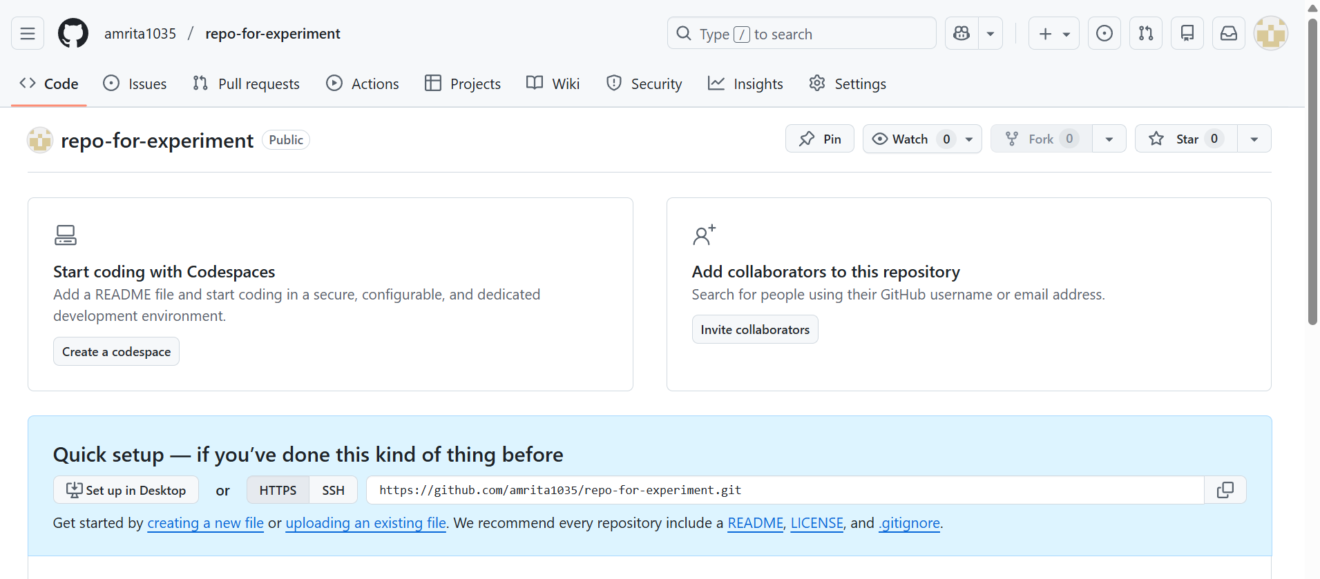
Result:
The project is successfully updated using the fork and pull request workflow. Collaboration is achieved through branching, code review, and merging changes into the main branch.

EXPERIMENT 10
Demonstrate how to work with Git branches and resolve merge conflicts when collaborating with others. Tasks:
1. Clone a shared repository to your local machine.
2. Create a new branch and switch to it.
3. Make changes to a file (e.g., update a README or modify code in a specific function).
4. Commit your changes.
5. Push the changes to the remote repository.
6. Before merging, pull the latest changes from the main branch.
7. Switch back to your feature branch.
8. Merge the main branch into your feature branch.
9. If there are conflicts, resolve them manually by editing the conflicting files. After resolving conflicts, mark the conflicts as resolved.
10. Commit the resolved merge.
11. Push your feature branch with the merged changes to GitHub and create a pull request.
12. Submit a summary of the steps you performed, the conflicts you encountered, and how you resolved them.
Aim:
To demonstrate working with Git branches and resolving merge conflicts during collaboration using GitHub.
Procedure:
- Clone Repository
git clone https://github.com/username/repo.git
cd repo
- Create and Switch to Branch
git checkout -b feature-branch
- Make Changes
  - Edit a file (e.g., README.md or code file).
- Commit Changes
git add .
git commit -m "Updated feature"
- Push Changes
git push origin feature-branch
- Pull Latest Main Branch
git checkout main
git pull origin main
- Switch Back to Feature Branch
git checkout feature-branch
- Merge Main into Feature Branch
git merge main
- Resolve Merge Conflicts (if any)
  - Open conflicted file → you’ll see:
<<<<<<< HEAD
your changes
=======
other changes
>>>>>>> main
  - Edit and keep correct content.
  - Remove conflict markers.
- Mark as Resolved & Commit
git add .
git commit -m "Resolved merge conflict"
- Push and Create Pull Request
git push origin feature-branch
- Go to GitHub → Create Pull Request.
OUTPUT

Result:
Git branching and merge conflict resolution were successfully performed, ensuring smooth collaboration and integration of changes.

